Tracy Efaw
On-Line Curriculum Project
Kennesaw State University
October 23, 2011
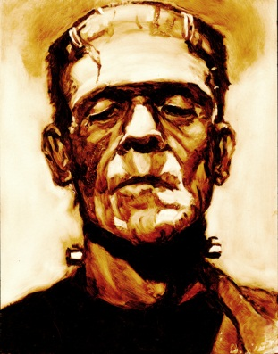

“Researching Contemporary Issues with Themes of Megalomania found in Frankenstein”
BWAHHAHAAHAAA!!

Yes…this sounds much harder than it really is, but the students, so far, are LOVING it! This project has already begun. It is based on a mini-research project we have been doing which is related to the GPS standards on informational text (scientific articles), and connected with the themes in the book Frankenstein. Attached, please find the research handout along with the “rubric” related to their final product.

As I read Chapter 8 in Roblyer about internet-based projects, I began to share my learning and my excitement with my gifted class. Instead of coming up with a boring PowerPoint, poster, or report about my students’ research findings, I decided to devote my “warm up” time each day in class to sharing something new with them about things they could use on the internet to present their findings in a new and innovative way. I am leaving it very open for them to make their own decisions, but they will get to choose from one of the following:

- Create a “PREZI” at www.prezi.com
- Create a webpage to house and reflect upon research information at www.weebly.com
- Create a presentation using “voice thread” at http://voicethread.com
- Create a special poster with embedded music, text, and video at http://www.glogster.com/

The standards this project touches are as follows:

ELA8R1: For informational texts, the student reads and comprehends in order to
develop understanding and expertise and produces evidence of reading that:
a. Analyzes and evaluates common textual features (e.g., paragraphs, topic sentences,
concluding sentences, introduction, conclusion, footnotes, index, bibliography).
b. Identifies the difference between the concepts of theme in a literary work and
author’s purpose in an expository text.

ELA8RC2 The student participates in discussions related to curricular learning
in all subject areas. The student
a. Identifies messages and themes from books and papers in all subject areas.
b. Responds to a variety of texts in multiple modes of discourse.
c. Relates messages and themes from one subject area to those in another area.
d. Evaluates the merits of texts in multiple subject disciplines.
e. Examines the author’s purpose in writing.
f. Recognizes and uses the features of disciplinary texts (e.g., charts, graphs, photos,
maps, highlighted vocabulary).

LoTi Level 4a

Based on a very good PowerPoint I found on the internet, presented by our very own Dr. Traci Redish, I discovered some interesting information about LoTi levels. It’s about integrating technology based on Blooms Taxonomy. At LoTi Level 4a, technology is integrated at a Mechanical level. According to Dr. Moersch (the developer of this PowerPoint), there is a “heavy reliance on “pre-packaged” materials and outside resources to implement student-centered learning experiences.” (www.edtech.kennesaw.edu/videos/LoTi%20Presentation.ppt) The same PowerPoint explained that technology projects at this level should emphasize the following:

  - Solving Authentic Problems
  - Higher levels of cognitive processing
  - In-depth examination of the content
  - Student Action
  - Student Collaboration
  - Issue Resolution

Having found this PowerPoint, I can see where my students’ project would indeed come in at this LoTi Level 4, because they must connect contemporary issues to the themes in a book which is almost 200 years old. Additionally, they have to conduct research into a chosen topic and evaluate and synthesize the information they find into a technology presentation that is understandable and meaningful. How exciting is that?!
Please find the attached research project handout and description of project expectations that is coming due on November 1, 2011.

Frankenstein and Controversy!!
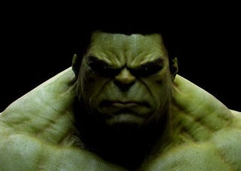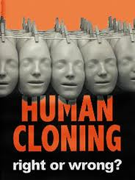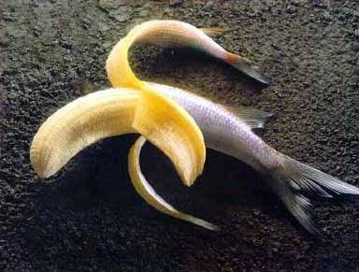

The story of Frankenstein might have been written in the early 19th century, but oh my, how we still hear about old Victor Frankenstein even today! As promised, we are going to embark on a research adventure of exploration into the mysteries of modern science and how we continue to tamper with Mother Nature even today. (especially today!)
Below is a list of topics from which you can choose. Please choose something that will be new and exciting to you. You will complete the attached handout and choose from a variety of ways to communicate your final research to the rest of the class.
- stem cell research
- cloning
- genetic engineering
- euthanasia
- thalidomide
- vaccinations
- eugenics
- nanotechnology
- prosthetics (in athletic competition)
- organ donation for money
- “death panels”
- nuclear weapons

Controversy? 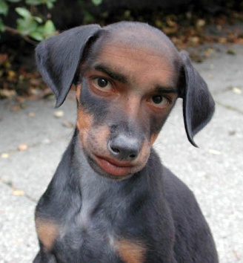
Who doesn’t LOVE Controversy!
You have been a list of controversial topics to explore. The common thread that runs between them all is the idea of absolute power and the perception of man’s attempt to play God. The goal is to learn as much BASIC information as you can about the topic, with the idea of becoming an “expert” in your field. A controversy generally has two sides, so you will want to look at both sides of the issue to learn as much as you can. From the information that you gather, you will be challenged to do a number of activities over the next several weeks in which your expertise will come in handy!
Below are some questions to guide your research. If you need more space than what has been provided for you to elaborate on your answers, please feel free to use an extra piece of notebook paper. Please complete each question and list the resources you use on the space provided for that. Please use a minimum of four different resources during the course of your research. You are also required to locate and read (in their entirety) two articles related to your topic of choice.

- Define your topic. My topic is ____________________________________________________ . ________________________________________________________________________________________________________________________________________________________________________________________________________________________________________________________________________________________________________________________

- Explain the problems that exist as a result of _______________________________ (your topic). Identify and describe at least 3 major problems you understand about your topic.
__________________________________________________________________________________________________________________________________________________________________________________________________________________________________________________________________________________________________________________________________________________________________________________________________________________________________________________________________________________________________________________________________________________________________

- What are your thoughts about your topic? What makes you think the way you do about your topic? What influences your thoughts? Parents? TV? Religion? ________________________________________________________________________________________________________________________________________________________________________________________________________________________________________________________________________________________________________________________
____________________________________________________________________________________________________________________________________________________________

- What kinds of controversy affect ________________________________ (your topic)? List each controversy and explain the nature of that controversy.
______________________________________________________________________________________________________________________________________________________________________________________________________________________________________________________________________________________________________________________________________________________________________________________________________
______________________________________________________________________________

- A controversy is defined as “a dispute, especially a public one, between sides holding opposing views. What are the “sides” of each controversy you have listed above?
____________________________________________________________________________________________________________________________________________________________________________________________________________________________________________________________________________________________________________________________________________________________________________________________________________________________________________________________________________________

- In the novel Frankenstein, the main character, Victor Frankenstein, is so overtaken by his own self-importance and vanity…his own desire for fame and recognition…that he crosses over acceptable boundaries of Science and “plays God” by creating a being out of the body parts of deceased people, creating a “monster.” How does ___________________________ (your topic)
fulfill that same role? How would the Romantics feel about this controversy? (see your notes on Romanticism). ________________________________________________________________________________________________________________________________________________________________________________________________________________________________________________________________________________________________________________________
______________________________________________________________________________

Sources
- Article Title__________________________________________________________________
Author ______________________________________________________________________
Book/MagazineTitle ___________________________________________________________
Year of Publication _________________________________Pages_______________________

- Article Title__________________________________________________________________
Author ______________________________________________________________________
Book/MagazineTitle ___________________________________________________________
Year of Publication _________________________________Pages_______________________

- Article Title__________________________________________________________________
Author ______________________________________________________________________
Book/MagazineTitle ___________________________________________________________
Year of Publication _________________________________Pages_______________________

- Article Title__________________________________________________________________
Author ______________________________________________________________________
Book/MagazineTitle ___________________________________________________________
Year of Publication _________________________________Pages_______________________

- Article Title__________________________________________________________________
Author ______________________________________________________________________
Book/MagazineTitle ___________________________________________________________
Year of Publication _________________________________Pages_______________________

- Article Title__________________________________________________________________
Author ______________________________________________________________________
Book/MagazineTitle ___________________________________________________________
Year of Publication _________________________________Pages_______________________

- Article Title__________________________________________________________________
Author ______________________________________________________________________
Book/MagazineTitle ___________________________________________________________
Year of Publication _________________________________Pages_______________________

- Article Title__________________________________________________________________
Author ______________________________________________________________________
Book/MagazineTitle ___________________________________________________________
Year of Publication _________________________________Pages_______________________

The Contemporary Frankenstein
Connecting Literary Themes with Modern Informational Writing

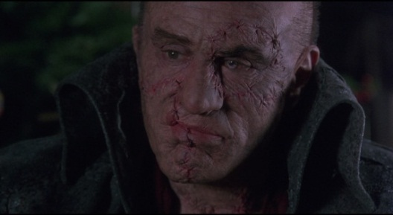

We have done a good bit of research on the issue of our choice (see research handout), and we have been reading and discussing the themes that run through the amazing novel, Frankenstein. Now it is time to put two and two together and “show what you know.” Not only are you going to teach the class about the research you have discovered and make connections between the contemporary issue you chose and the themes of Frankenstein, you are also going to present your findings in new and innovative ways.

Please choose from one of the following ways to present your information to the class:

- Create a “PREZI” at www.prezi.com
- Create a webpage to house and reflect upon research information at www.weebly.com
- Create a presentation using “voice thread” at http://voicethread.com
- Create a special poster with embedded music, text, and video at http://www.glogster.com/

The sky is the limit on what you can do with each of these media. What I have shown you in class is merely the tip of the iceberg…and we all know how DEEP icebergs can go!! I expect to see amazing things from you as you explore new ways of presenting valuable information. However, there are some required elements, all of which I want to make sure you include in your presentation. They are as follows:

- You must explain what you learned about your topic within the medium you have selected. Be sure to answer the who, what, when, where, and how-type questions. Remember, you are teaching your classmates about what you have learned. On your presentation day, YOU are the teacher!!
- You must make a minimum of three connections from your research to the Frankenstein text. Please use quotes from the book and reference the page numbers from which you obtained the quote.
- Review the notes you have taken about the themes that run through Frankenstein, and be sure to provide a commentary about how some of these themes connect with the issues raised by your contemporary topic. For example, when we look at genetic engineering of food, and we know that the jury is still out on long term effects of these products, does this not connect with the kind of scientific irresponsibility we saw Victor display when he created the monster with no forethought as to the possible outcomes? Below are a list of some of the themes we have discussed as a class:
- Isolation
- Scientific irresponsibility
- Power
- Corruption
- Obsession

Evaluation Rubric
The Rubric below will be utilized to grade your project and presentation.

Criteria | Scale of  1-10
Explanation you have provided about your topic of choice is thorough and meaningful.
You have made a minimum of 3 connections from your topic to the Frankenstein text.
You have referenced page numbers each time you have referred to Frankenstein.
You have made a connection with some of the themes we have reviewed, related to Frankenstein.
Your presentation is interesting, and it is apparent you are very prepared, and understand your topic well enough to teach it.
The technology you have selected and the way you have utilized the technology aids in providing understanding and engagement among your peers.
You have a clear command of the technology choice you have selected, and your presentation is not only informative, but impressive!
You were able to answer questions from your peers about the subject matter you presented.
You were able to effectively synthesize the information you have researched into a creative presentation.
Your presentation skills are professional and well-rehearsed.

Commentary: ______________________________________________________________________________________________________________________________________________________________________________________________________________________________________________________________________________________________________________________________________________________________________________________________________________________________________________________________________________________________________________________________________________________________________________________________________________________________________________________________________________________________________________________________
________________________________________________________________________________________________________________________________________________________________________________________________________________________________________________________________________________________________________________________

