This Evening’s Agenda
“Common Core: Wising Up to Wikis”

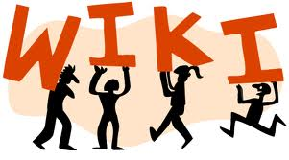

Please divide into groups by grade level.

Introduction and Rationale

Teaching the Basics of Wikis/Creating Your Own

Classroom Applications: Many Ways to Use Wikis in the Classroom

Time to Work in your Groups

Follow Up Session in your Data Teams/Planning Teams at School

Presented by Tracy Efaw, Mimi Givarz, and June Vance

